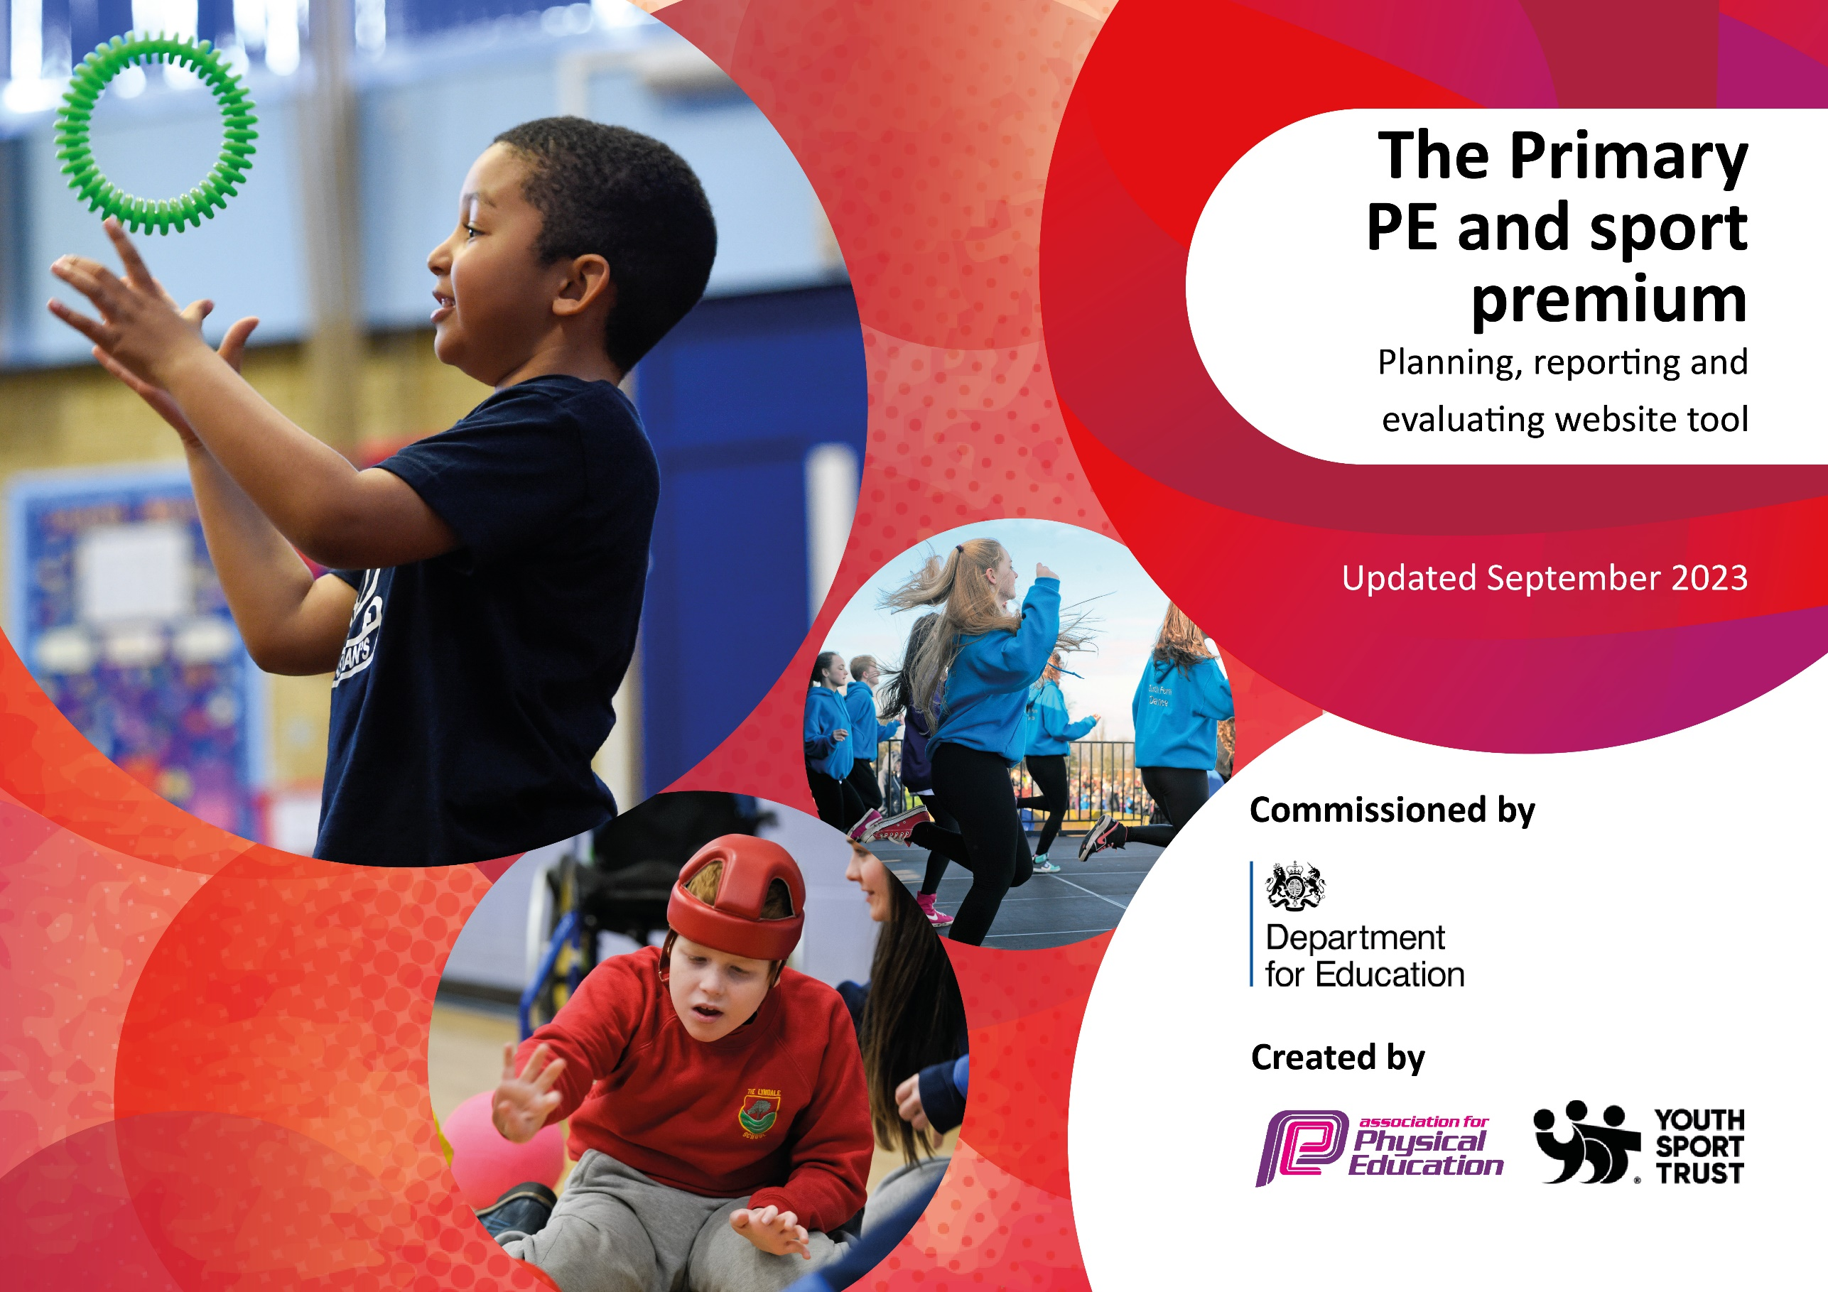

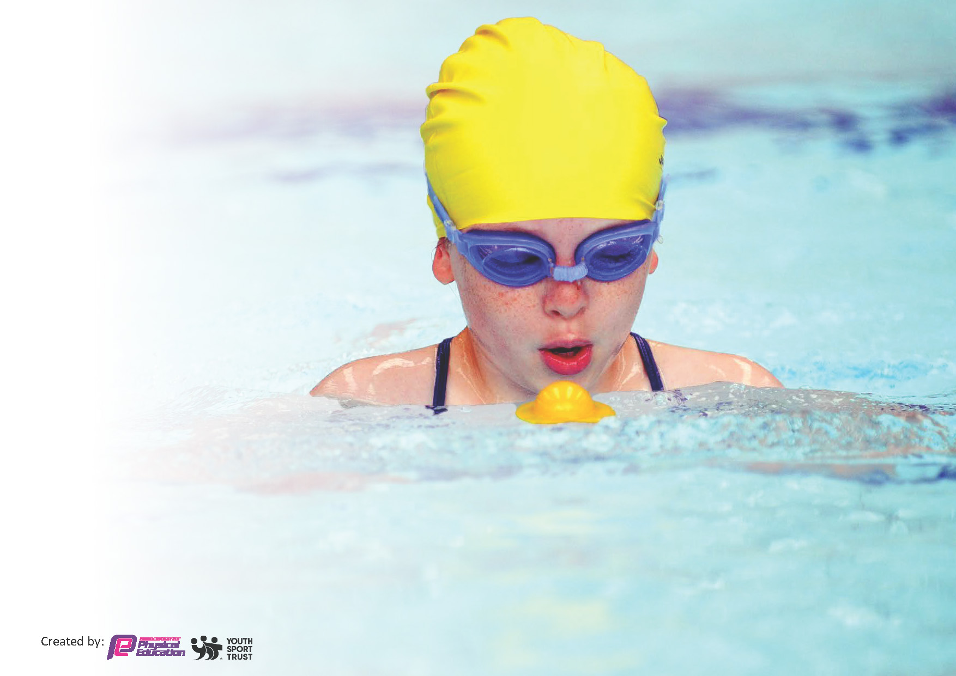
This template can be used for multiple purposes:
by:
- It enables schools to effectively plan their use of the Primary PE and sport premium
- It helps schools to meet the requirements (as set out in guidance) to publish information on their Primary PE and sport premium
- It will be an effective document to support Ofsted inspections enabling schools to evidence progress in Physical Education (PE) and evidence swimming attainment, which forms part of the PE National Curriculum. We would recommend schools consider
the Intent, Implementation and Impact of any spend, as examined within the Education Inspection Framework.

It is important that your grant is used effectively and based on school need.

Schools must use the funding to make additional and sustainable
improvements to the quality of the PE, School Sport and Physical Activity (PESSPA)
they offer. This means that you should use the Primary PE and sport premium to:

- Build capacity and capability within the school to ensure that improvements made now will benefit pupils joining the school in future years
- Develop or add to the PESSPA activities that your school already offers.

The Primary PE and sport premium should not be used to fund capital spend projects; the school’s core budget should fund these. Further detail on capital expenditure can be found in the updated Primary PE and sport premium guidance.

The Primary PE and sport premium guidance, outlines 5 key priorities that funding should be used towards. It is not

necessary that spending has to meet all the key priorities, you should select the priorities that you aim to use any funding towards.

Although completing this template is not a requirement for schools, schools are required to publish details of how they spend this funding. Schools must also outline what the impact this funding has had on pupils’ PE and sport participation and attainment and how any spending will be sustainable in the future. All funding must be spent by 31st July 2024.

The Department for Education has worked closely with the Association for Physical Education (afPE) and the Youth Sport Trust (YST) to develop this template and encourages schools to use it. This template is an effective way of meeting the reporting requirements of the Primary PE and sport premium.
Review of last year’s spend and key achievements (2022/2023)

We recommend you start by reflecting on the impact of current provision and reviewing your previous spend.

Activity/Action | Impact | Comments
Dorset County Champions at Netball  Second in county in both handball and Indoor Athletics.  Gold School games mark.  Increase sporting opportunities for all children.  Maintain 2x hours of pe for each class.  Improved facilities and equipment so children can make necessary progress. | Raise awareness of sports and successes of the school  More pupils meeting their daily physical activity goal, more pupils encouraged to take part in PE and Sport Activities.  Better equipment has helped pupils to develop their sporting techniques. | A very successful year where every child was given 2 hours of PE.  A successful sports partnership with the Purbeck school which enables us to offer a diverse range of sporting opportunities to children.

Key priorities and Planning
This planning template will allow schools to accurately plan their spending.

Action – what are you planning to do | Who does this action impact? | Key indicator to meet | Impacts and how sustainability will be achieved? | Cost linked to the action
Maintain lunchtime sport sessions/activities for pupils. | teaching staff  pupils – as they will take part. | Key indicator 2 -The engagement of all pupils in regular physical activity – the Chief Medical Officer guidelines recommend that all children and young people aged 5 to 18 engage in at least 60 minutes of physical activity per day, of which 30 minutes should be in school.  Key indicator 4: Broader experience of a range of sports and activities offered to all pupils. | More pupils meeting their daily physical activity goal, more pupils encouraged to take part in PE and Sport Activities. | £0 costs as staff does this.

e.g. CPD for teachers.  Supporting the Purbeck sports partnership.  Sport resources to improve quality of teaching  Use of high quality coaching to raise sporting ability of all pupils. KS1 & ks2  To keep using complete PE access to detailed planning and assessment tool  Getting to and from sporting events  High quality sporting equipment | Primary generalist teachers.  Sporting fixtures and opportunities consistently throughout the school year.  Raise standard of pupils and help differentiation.  All children and staff  All children and staff  Childrens ability to participate in events  Children having high quality equipment so can improve their skills and have increased opportunities at a range of sports. | Key Indicator 1: Increased confidence, knowledge, and skills of all staff in teaching PE and sport.  Key indicator 5: Increased participation in competitive sport.  Key indicator 5: Increased participation in competitive sport.  Key Indicator 1: Increased confidence, knowledge, and skills of all staff in teaching PE and sport.  Key indicator 2 -The engagement of all pupils in regular physical activity  Key indicator 3  Key indicator 2  Key indicator 1,2,3,4,5 | Primary teachers more confident to deliver effective PE supporting pupils to undertake extra activities inside and outside of school, including teaching water safety and swimming and as a result improved % of pupil’s attainment in PE.  A consistent approach working well for over 10 years now.  Equipment looked after and maintained and pupils treat with respect to last numerous of years.  Coaches passing on their skills to all staff. Through team teaching and planning.  Once bought into the scheme renewal price is very affordable £105  Children can attend all opportunities. Again members of staff carry this action out.  Improve ability, equipment can last years. | Included in sports partnership .for 5 teachers to undertake CPD. £413.24  £1800  £2476.21  £7437.93  £105  £958.66  £4468.99  Total spend £17,660

Key achievements 2023-2024
This template will be completed at the end of the academic year and will showcase the key achievements schools have made with their Primary PE and sport premium spending.

Activity/Action | Impact | Comments
Dorset county netball champions 3 years in a row.  Second in indoor Athletics in Dorset  Starting a girl’s football tournament up (The Purbeck Cup)  Increased girl participation in football.  Targeted clubs for a range of all pupils.  School Games Gold mark achieved and applying for Platinum  Successful competitive sports day where every child takes part and earns points for there house.  Increased connections with | Maintain our focus as concentrating on individual targeted sports.  Promoting and championing girls sports. Giving equal opportunities.  Clubs to meet needs of all pupils, higher participation rate  Increasing the awareness of competitive sport. | 3 x winners in a row  Successful connections with other schools, a tournament to last.  Increased awareness of sport  Parents impressed by sports day.

Swimming Data
Meeting National Curriculum requirements for swimming and water safety.
Priority should always be given to ensuring that pupils can perform safe self-rescue even if they do not fully meet the first two requirements of the National Curriculum programme of study

Question | Stats: | Further context  Relative to local challenges
What percentage of your current Year 6 cohort can swim competently, confidently and proficiently over a distance of at least 25 metres? | 93%
What percentage of your current Year 6 cohort can use a range of strokes effectively [for example, front crawl, backstroke, and breaststroke]? | 93%

What percentage of your current Year 6 cohort are able to perform safe self-rescue in different water-based situations? | 93%
If your schools swimming data is below national expectation, you can choose to use the Primary PE and sport premium to provide additional top-up sessions for those pupils that did not meet National Curriculum  requirements after the completion of core lessons. Have you done this? | No
Have you provided CPD to improve the knowledge and confidence of staff to be able to teach swimming and water safety? | No

Signed off by:

Head Teacher: | (Alan Frame)
Subject Leader or the individual responsible for the Primary PE and sport premium: | (Alex White) Year 5 Class Teacher and PE Lead
Governor: | (Phil Santos)
Date: | 9/7/2024

