# E:\Users\simon.roche\AppData\Local\Microsoft\Windows\Temporary Internet Files\Content.Word\Evidencing the Impact of the Primary PE and Sport Premium Template 2019 7.3 Images_Page_1.jpg

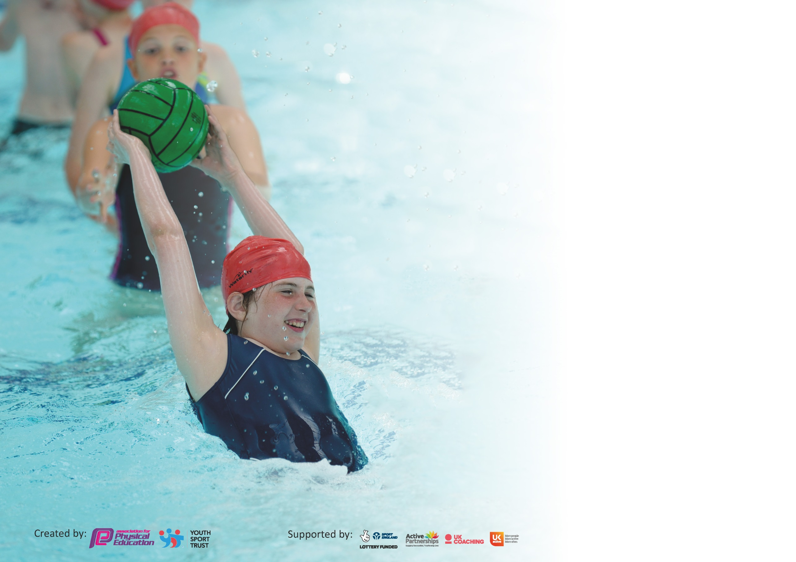

It is important that your grant is used effectively and based on school need. The [Education Inspection Framework](https://assets.publishing.service.gov.uk/government/uploads/system/uploads/attachment_data/file/843108/School_inspection_handbook_-_section_5.pdf) (Ofsted 2019 p64) makes clear there will be a focus on **‘whether leaders and those responsible for governors all understand their respective roles and perform these in a way that enhances the effectiveness of the school’**.

Under the [Quality of Education criteria](https://assets.publishing.service.gov.uk/government/uploads/system/uploads/attachment_data/file/843108/School_inspection_handbook_-_section_5.pdf) (p41) inspectors consider the extent to which schools can articulate their curriculum (INTENT), construct their curriculum (IMPLEMENTATION) and demonstrate the outcomes which result (IMPACT).

To assist schools with common transferable language this template has been developed to utilise the same three headings which should make your plans easily transferable between working documents.

Schools must use the funding to make **additional and sustainable** improvements to the quality of Physical Education, School Sport and Physical Activity (PESSPA) they offer. This means that you should

use the Primary PE and Sport Premium to:

* Develop or add to the PESSPA activities that your school already offer
* Build capacity and capability within the school to ensure that improvements made now will benefit pupils joining the school in future years

Please visit [gov.uk](https://www.gov.uk/guidance/pe-and-sport-premium-for-primary-schools) for the revised DfE guidance including the 5 key indicators across which schools should demonstrate an improvement. This document will help you to review your provision and to report your spend. DfE encourages schools to use this template as an effective way of meeting the reporting requirements of the Primary PE and Sport Premium.

We recommend you start by reflecting on the impact of current provision and reviewing the previous spend.

Schools are required to [publish details](https://www.gov.uk/guidance/what-maintained-schools-must-publish-online#pe-and-sport-premium-for-primary-schools) of how they spend this funding as well as on the impact it has on pupils’ PE and sport participation and attainment by the end of the summer term or by **31st July 2020** at the latest.

We recommend regularly updating the table and publishing it on your website throughout the year. This evidences your ongoing self-evaluation of how you are using the funding to secure maximum, sustainable impact. Final copy must be posted on your website by the end of the academic year and no later than the 31st July 2020. To see an example of how to complete the table please click [HERE](http://www.afpe.org.uk/physical-education/wp-content/uploads/afPE-Example-Template-Indicator-2018-Final.pdf).

Support for review and reflection - considering the 5 key indicators from DfE, what development needs are a priority for your setting and your pupils now and why? Use the space below to reflect on previous spend and key achievements and areas for development.

|  |  |
| --- | --- |
| Key achievements to date until July 2019: | Areas for further improvement and baseline evidence of need: |
| * Maintained our Gold Sports Award status. 3RD year running. * Partnerships with local providers provide extra-curricular outdoor education activities * Improved facilities so pupils have experience of full-court opportunities for competitive games. * Provide opportunities for pupils to have access to climbing play equipment during playtimes to enhance playtime experience and increase opportunities for physical activity. * Increase the size of our artificial playing surface to improve offer of high quality 2hrs of PE a week for all pupils in KS2. | Every child in KS2 to attend an extra curriculum club.  All children in KS2 to take part in a lunchtime intra house competition. |

|  |  |
| --- | --- |
| Meeting national curriculum requirements for swimming and water safety. |  |
| What percentage of your current Year 6 cohort swim competently, confidently and proficiently over a distance of at least 25 metres?  **N.B.** Even though your pupils may swim in another year please report on their attainment on leaving  primary school at the end of the summer term 2020. | 90% |
| What percentage of your current Year 6 cohort use a range of strokes effectively [for example, front crawl, backstroke and breaststroke]? | 90% |
| What percentage of your current Year 6 cohort perform safe self-rescue in different water-based situations? | 90% |
| Schools can choose to use the Primary PE and Sport Premium to provide additional provision for swimming but this must be for activity **over and above** the national curriculum requirements. Have you used it in this way? | Yes |

**Action Plan and Budget Tracking**

Capture your intended annual spend against the 5 key indicators. Clarify the success criteria and evidence of impact that you intend to measure to evaluate for pupils today and for the future.

|  |  |  |  |  |  |  |  |  |  |
| --- | --- | --- | --- | --- | --- | --- | --- | --- | --- |
| **Academic Year:** 2019/20 | **Total fund allocated:** £17,977 | | | **Date Updated: 3rd July 2020** | | |  | | |
| **Key indicator 1:** The engagement of all pupils in regular physical activity – Chief Medical Officer guidelines recommend that primary school pupils undertake at least 30 minutes of physical activity a day in school | | | | | | | Percentage of total allocation: | | |
| 58% | | |
| **Intent** | **Implementation** | | | | | **Impact** |  | | |
| Extension of the school artificial playing surface.  Development of climbing facilities for all pupils. | All children to maintain 30 minutes of physical activity daily:  Extension of artificial playing surface means lessons can carry on in all weathers. | | | Funding allocated: £10,578 | | Evidence of impact: what do pupils now know and what can they now do? What has changed?: | Sustainability and suggested next steps: | | |
| - Educate children in the value and benefits of a healthy active lifestyle.  - Ensure a high quality PE and school sport offer develops competent and confident young people with the aim of inspiring lifelong participation in physical activity.  - Provide better opportunities for daily physical activity. | - Through PE lessons and sport, ensure our children understand the role of movement in the development of their own physical literacy, fitness and well-being.  - Develop the PE curriculum to ensure lessons link to the multi-skills approach found in our PE policy.  - Build links with local community sports clubs through our SGO.  - Send staff on Youth Sport Trust Active Maths and Active English courses on the CPD programme.  - Twice weekly skipping for fitness for all pupils | | | Astro £7,350  Climbing wall  £2,564  Absolute Coaching £325  Skipping ropes £150  Fertilizer and grass seed £189 | | - Positive attitudes to health and well-being evident across the school  - Pupil concentration, commitment, self-esteem and behaviour improved for pupils participating in sports ambassador scheme  - Positive behaviour and a sense of fair play modelled by using Bronze Ambassadors to run lunchtime clubs for younger pupils  - Pupils’ activity at lunch and break increased  - Fewer lessons were cancelled due to bad weather.  Evidence -  - Curriculum map  - PE policy  - Registers of participation  - Extra-curricular data | - Monitor physical activity levels to ensure we consistently meet the government guidelines of at least 30 minutes a day for each child during school time.  -Use of Monitoring package to record data. (Absolute Coaching) | | |
| **Key indicator 2:** The profile of PESSPA being raised across the school as a tool for whole school improvement | | | | | | | Percentage of total allocation: | | |
| 12% | | |
| **Intent** | **Implementation** | | | | | **Impact** |  | | |
| Use of netball to promote girls sport throughout Ks2. Develop links with outside clubs.  Maintain boys participation in sport. | Actions to achieve. | | | Funding allocated: £2126 | | Evidence of impact: what do pupils now know and what can they now do? What has changed?: | Sustainability and suggested next steps: | | |
| - Use PE and sport to enable the development of life skills that are transferred to other curriculum areas, wider school and beyond.  - Use PE and sport to develop the whole person including thinking, social and personal skills?  - Use PE teaching to aid fine and gross motor skill development?  - Use sporting role models used to engage and raise achievement?  - Ensured PE and school sport is visible in the school (assemblies, notice boards,  school website, local press, pupil reward and recognition of pupils)  - Raise awareness of the best places to take part in sport and physical activity outside of school.  Use active lessons to increase physical activity levels and learning.  - Develop Bronze Ambassadors to support active playtimes and support extra-curricular activities. | - As a school we contribute funding to sustain the Purbeck School Sport Partnership which provides the following opportunities:  • Additional competitions outside of the School Games programme  • Comprehensive CPD programme  • PE Conference  • Outdoor activity days  • Primary Leadership Academy  • Purbeck Sports Awards  • Youth Sport Trust Primary Membership  • Support from Dan Moody for team teaching and staff training.  - Introduce Youth Sport Trust MY Personal Best programme in school. Training course attended and resources being utilised.  - Develop a team of sports leaders & Bronze Ambassadors through the Purbeck Primary Leadership Academy. Use the Dorset leadership awards to support pupils on their leadership pathway. | | | Purbeck School Sports Partnership £1750  Dorset PE Conference £120  Supply costs  £161  Sports kit for fixtures £95 | | - Personal development (physical skills, thinking skills, social skills and personal skills) integrated into PE curriculum.  - Positive impact on attainment and achievement, behaviour and attendance. Behaviour consistently good across school and attendance above local averages.  - PE physical activity and school sport have a high profile and are celebrated across the life of the school. Pupils mention sport as one of the things that makes St Mary’s a good school.  - SMSC - Children learn to respect and work with each other, exercise self-discipline and act in a safe and sensible manner.  -More girls take part in lunchtime sport.  Bronze ambassador girls lead other clubs for girls at lunchtime.  - Full-size netball court in playground meant girls were able to practise more & remained unbeaten all season. Reached county finals but unfortunately cancelled due to Covid 19. | - Identify the positive impact that PE and school sport has on academic achievement, behaviour and safety, attendance, health and wellbeing and SMSC.  Review School development plan, Whole school policies/PE policy.  - Use opportunities in PE to reinforce main curriculum drivers  - Use PE conference to review, evaluate and plan for the next academic year. | | |
| **Key indicator 3:** Increased confidence, knowledge and skills of all staff in teaching PE and sport | | | | | | | | | Percentage of total allocation: |
| 2% |
| **Intent** | | **Implementation** | | | **Impact** | | | |  |
| Pupils to have greater understanding what they have to do to improve in PE.  Use of assessment for learning to help teachers plan lessons. | | More structure and planning to lessons to improve children’s development.  Organised,consistent assessment through games/activities. | Funding allocated:  £333 | | Evidence of impact: discussion with pupils and other forms of subject monitoring show that pupils have a good understanding of where they are and what they need to do next? | | | | Sustainability and suggested next steps |
|  | |  |  | |  | | | |  |
| - Raise the quality of learning and teaching in PE and school sport by providing support to deliver broad, balanced and inclusive high quality PE and school sport provision (within and beyond the curriculum) to raise pupils’ attainment. | | Opportunities for staff to access CPD opportunities through the Purbeck School Sport Partnership CPD programme.  Use specialist coaches and providers for team teaching & staff training to increase the knowledge and confidence of staff in delivering PE.  Purchase quality assured resources to support teachers and support staff.  Provide external cpd for all staff on Active Learning  Provide internal cpd from PE subject leader for all staff | Supply costs to cover cpd  £163  Gymnastics scheme of work  £170 | | - Increased staff knowledge and understanding  - All teachers able to confidently plan, teach and assess National Curriculum PE  - More confident and competent staff evidenced through feedback and lesson observations  - More sustainable workforce that includes young leaders.  - Quality of PE provision improved  - Increased pupil participation in competitive activities and festivals  - Wider range of sporting opportunities available  - Good practice has been shared with other schools in the Purbeck Partnership  - A more inclusive curriculum which inspires and engages all pupils including harder to reach has been delivered  - Increased capacity and sustainability going forwards with new staff developing expertise and pupils taking on increasingly significant leadership role. | | | | - Review staff confidence and competence in delivering high quality PE and school sport and encourage staff to take up upcoming CPD opportunities |
| **Key indicator 4:** Broader experience of a range of sports and activities offered to all pupils | | | | | | | | | Percentage of total allocation: |
| 23% |
| **Intent** | | **Implementation** | | | **Impact** | | | |  |
| - Provide opportunities to take part in a diverse range of school sports through extra-curricular clubs, competitions and events. | | Provide the equipment and the coaching to help this take place. | Funding allocated:  £4125 | | Evidence of impact: what do | | | | Sustainability and suggested |
|  | |  |  | |  | | |
| Hockey coaching part of PE curriculum and after school provision.  Outdoor education accessed by all  pupils and for targeted groups.  Strong links with local hockey, tennis and cricket clubs.  New equipment to help give pupils greater opportunity.  For example tennis nets, vault, trampette  Handball, new age curling, netball posts of varying height.  Yoga sessions weekly for Reception, Year 1 and Year 2 pupils  Provide opportunities for small group of pupils, including SEND who are non-swimmers to have extra swimming tuition weekly to help them catch up | | - Provide opportunities for children with SEND, the least confident and the least active to attend exciting, varied and a new range of activities through the school sport partnership.  - Review extra-curricular activities through pupil voice/Bronze Ambassadors.  - Employ sports coaches to provide age and stage appropriate extra-curricular sporting clubs and to improve sports skills in children through increased opportunities in school and the wider community.  - Complete inclusive health check on the School Games Website to review our PE and school sport offer in terms of inclusion and use the action plan to develop our offer.  Remarking of school playground | Yoga sessions £180  Remarking of school playground £820  Hockey coaching  £375  Full-size tennis net £250  Resources £1700  Swimming booster sessions  £800 | | - High proportion of disaffected pupils engaged or re-engaged  - Increased overall pupil participation  - Enhanced, extended and inclusive extra-curricular provision at lunchtimes and after school  - Improved behaviour and attendance and reduction of low level disruption particularly at lunchtimes  - Increased awareness of opportunities available in the community and more pupils joining local clubs especially football, cricket, hockey  - improved technical and tactical and understanding of a range of sports  - Development of wider life skills which build on from the PE lessons, i.e. communication, teamwork, fair play and leadership  Evidence includes - Curriculum map, Inclusive health check, Registers of participation, Extra-curricular data, student/staff surveys | | | | - Carefully select outside providers and ensure they understand our vision for school sport and that the opportunities they offer contribute to that vision. |

|  |  |  |  |  |
| --- | --- | --- | --- | --- |
| **Key indicator 5:** Increased participation in competitive sport | | | | Percentage of total allocation: |
| 5% |
| **Intent** | **Implementation** | | **Impact** |  |
| All pupils in year 6 to represent the school in at least one sporting event.  And to take part in one intra house sport competition.  To pursue every opportunity to get as many pupils as possible in KS2 taking part in sport. | Record down all events and make sure all pupils have been selected for events throughout the year. | Funding allocated:  £815 | Evidence of impact: what do pupils know now and what can they do? What has changed? | Sustainability and suggested next steps. |
|  |  |  |  |  |
| - Provide opportunities for all children to challenge themselves through both intra and inter school sport where the children's motivation, competence and confidence are at the centre of the competition and the focus is on the process rather than the outcome.  - Increased participation in School Games competitions.  - Providing opportunities for children with SEND, the least active and the least confident to attend competitions and events.  - Select children who we feel would benefit most from the opportunities available in the Purbeck Partnership events calendar. | - Engage with partnership coordinators Shelley Hamblin and Dan Moody attend competitions run by the Purbeck School Sport Partnership.  - Engage more staff/parents/volunteers and young leaders to support attendance at competitions.  - Use external coaches to run competitions to increase pupils’ participation.  - Identify a set number of competitions/events to provide transport to.  School to provide transport to all these events. | Transport costs £200  Staffing costs to cover competitive fixtures £615 | - 100% of young people represent their school in year 6  - 50% of young people part of community clubs that the school has links to.  -100% of children took part in a intra house competition year 5&6  Evidence includes -  - School Games Mark  - Competition/ events calendar  - School achievements at competitive events  - Photos displayed at school and on website  - Competition reports/results  St Mary’s reached County finals in football (boys and girls), athletics and netball. Second in Country Indoor Athletics Final | - Review attendance data and identify children for appropriate opportunities.  - Continue to attend Purbeck Partnership half-termly meetings to help shape the offer to ensure it is appropriate for our pupils and of the highest quality. |

|  |  |
| --- | --- |
| Signed off by | |
| Head Teacher: | Maria Gadston |
| Date: | 6th July 2020 |
| Subject Leader: | Alex White |
| Date: | 26th June 2020 |
| Governor: | Tom Norman |
| Date: | 8th July 2020 |