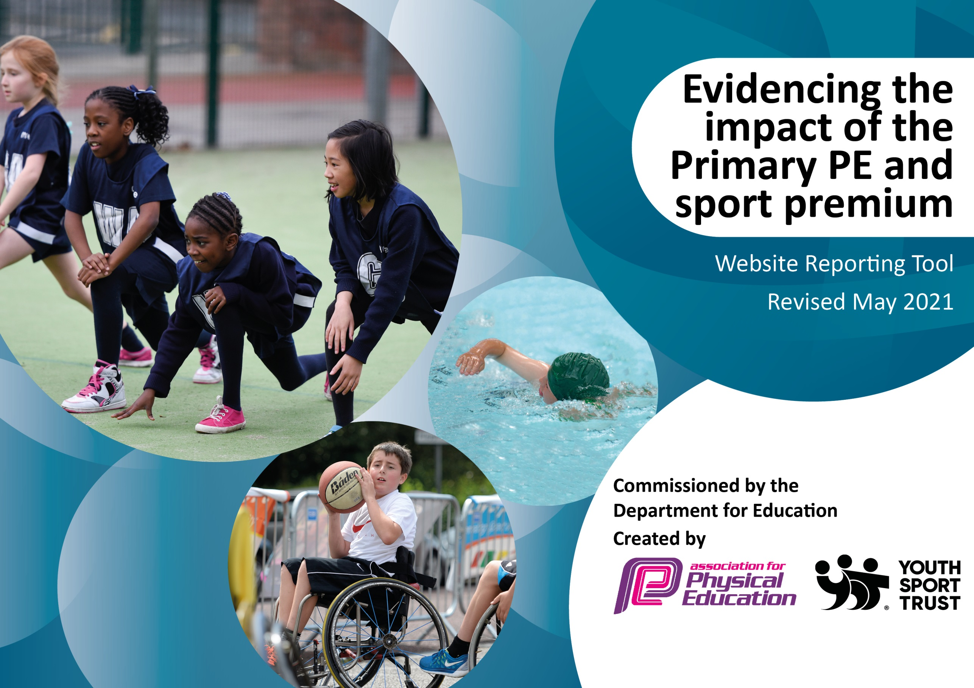

It is important that your grant is used effectively and based on school need. The Education Inspection Framework (Ofsted 2019 p64) makes clear there will be a focus on **‘whether leaders and those responsible for governors all understand their respective roles and perform these in a way that enhances the effectiveness of the school’**.

Under the Quality of Education criteria (p41) inspectors consider the extent to which schools can articulate their curriculum (INTENT), construct their curriculum (IMPLEMENTATION) and demonstrate the outcomes which result (IMPACT).

To assist schools with common transferable language this template has been developed to utilise the same three headings which should make your plans easily transferable between working documents.

Schools must use the funding to make **additional and sustainable** improvements to the quality of Physical Education, School Sport and Physical Activity (PESSPA) they offer. This means that you should use the Primary PE and sport premium to:

* Develop or add to the PESSPA activities that your school already offer
* Build capacity and capability within the school to ensure that improvements made now will benefit pupils joining the school in future years
* The Primary PE and sport premium should not be used to fund capital spend projects; the school’s budget should fund these.

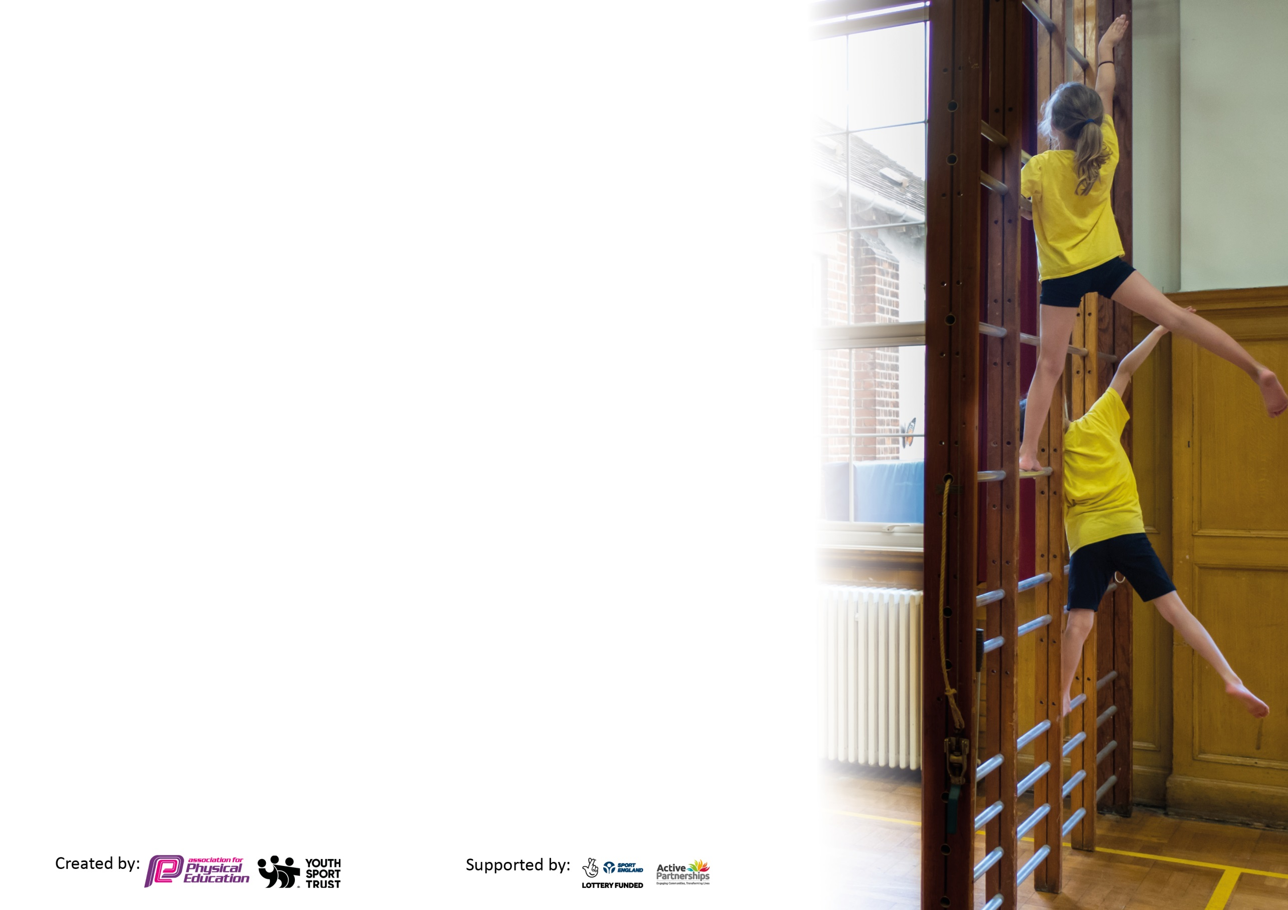

Please visit gov.uk for the revised DfE guidance including the 5 key indicators across which schools should demonstrate an improvement. This document will help you to review your provision and to report your spend. DfE encourages schools to use this template as an effective way of meeting the reporting requirements of the Primary PE and sport premium.

We recommend you start by reflecting on the impact of current provision and reviewing the previous spend.

Schools are required to publish details of how they spend this funding, including any under-spend from 2019/2020, as well as on the impact it has on pupils’ PE and sport participation and attainment by the end of the summer term or by **31st July 2021** at the latest.

We recommend regularly updating the table and publishing it on your website throughout the year. This evidences your ongoing self-evaluation of how you are using the funding to secure maximum, sustainable impact. Final copy must be posted on your website by the end of the academic year and no later than the 31st July 2021. To see an example of how to complete the table please click HERE.



Please note: Although there has been considerable disruption in 2020 it is important that you publish details on your website of how you spend the funding - this is a legal requirement.

Support for review and reflection - considering the 5 key indicators from DfE, what development needs are a priority for your setting and your pupils now and why? Use the space below to reflect on previous spend and key achievements and areas for development.

N.B. In this section you should refer to any adjustments you might have made due to Covid-19 and how these will influence further improvement.

|  |  |
| --- | --- |
| Key achievements to date until July 2020: | Areas for further improvement and baseline evidence of need: |
| * The Daily Mile continues and is successfully completed every day. * The installation of an artificial pitch so more space to teach PE in all weathers. * An improvement was seen in the quality of PE lessons within the school due to staff CPD and signing up to Complete PE. * New sports equipment was purchased to enable extra opportunities to take part in a wide variety of sports. This included cricket, handball, hockey, football and netball equipment. * New playground markings to support the teaching of PE. * A wider variety of extra-curricular sports were provided by teachers and staff after school, including, boys, girls and mixed football club, netball club, running club, multi-sports club, hockey.   Every Tuesday 3:15pm – 4:20pm. All sports clubs are free of charge   * Children were given every opportunity to take part in competitive sport. This included netball and football tournaments and matches with local schools. * Within the last 5 years we have come second in Dorset at netball and athletics. * Maintaining our Gold Award for Physical Education. | * More children in years 3 and 4 to take part in lunch time clubs. * Swimming to be more accessible for all in KS2. |

Did you carry forward an underspend from 2019-20 academic year into the current academic year? YES/NO * Delete as applicable

**Total amount carried forward from 2019/2020 £0**

**+ Total amount for this academic year 2020/2021 £17720**

**= Total to be spent by 31st July 2021 £12581.31**

|  |  |
| --- | --- |
| Meeting national curriculum requirements for swimming and water safety.  N.B Complete this section to your best ability. For example you might have practised safe self-rescue techniques on dry land which you can transfer to the pool when school swimming restarts.  **Due to exceptional circumstances priority should be given to ensuring that pupils can perform safe self rescue even**  **if they do not fully meet the first two requirements of the NC programme of study.** |  |
| What percentage of your current Year 6 cohort swim competently, confidently and proficiently over a distance of at least 25 metres?  **N.B.** Even though your pupils may swim in another year please report on their attainment on leaving primary school at the end of the summer term 2021.  Please see note above. | 81% |
| What percentage of your current Year 6 cohort use a range of strokes effectively [for example, front crawl, backstroke and breaststroke]?  Please see note above. | 62% |
| **What percentage of your current Year 6 cohort perform safe self-rescue in different water-based situations?** | 31% |
| Schools can choose to use the Primary PE and sport premium to provide additional provision for swimming but this must be for activity **over and above** the national curriculum requirements. Have you used it in this way? | No |

**Action Plan and Budget Tracking**

Capture your intended annual spend against the 5 key indicators. Clarify the success criteria and evidence of impact that you intend to measure to evaluate for pupils today and for the future.

|  |  |  |  |  |
| --- | --- | --- | --- | --- |
| **Academic Year:** 2020/21 | **Total fund allocated:** £1850 | **Date Updated:** | |  |
| **Key indicator 1:** The engagement of all pupils in regular physical activity – Chief Medical Officers guidelines recommend that primary school pupils undertake at least 30 minutes of physical activity a day in school | | | | Percentage of total allocation: |
| 46% |
| **Intent** | **Implementation** | | **Impact** |  |
| **Make sure all pupils are taking part in regular physical exercise. 2 hours a week teaching time. 75mins morning run time per week. Children attending at least 2 lunch time clubs a week. 1 hour.** | **Actions to achieve.** | **Funding allocated:** | **Evidence of impact: what do pupils now know and what can they now do? What has changed?:** | **Sustainability and suggested next steps:** |
| The benefit of regular and consistent physical activity. Increasing the Daily morning run from 10 minutes to 15.  Additional achievements:  Purchase equipment for PE, lunch time  activities and sports day.  • Enables staff to deliver more precise  lessons with aid of resources.  • Creates calmer lunchtimes with less  issues to resolve.  • Increases pupil participation in  activities.  • Increase interest in sport and a  healthy lifestyle.  • Motivates children to perform on  Sports Day.  • Improves attitudes to learning.  • Contributes towards the  engagement of all pupils in regular  physical activity.  • Provides a broad experience of  sports and activities.  All pupils across the school are subject to two hours of PE a week.  - Ensure a high quality PE and school sport offer develops competent and confident young people with the aim of inspiring lifelong participation in physical activity.  Provide extra club opportunities by using resident sports coach. | A path built so pupils can access the morning run safely and securely. This has led to morning runs not being missed and astro area accessible throughout the year.  • PE teacher organises/runs lunch time activities. Discussions with lunch time supervisors on the plan of the half term.   * Monitor the variety of physical   activities on offer to the children during  break, lunch and after school.  • Regular checks of the PE cupboard to check for wear and  tear and replacements needed.  - As a school we contribute funding to sustain the Purbeck School Sport Partnership which provides the following opportunities:  • Complete PE  • Youth Sport Trust Primary Membership  • Additional competitions outside of the School Games programme  • Comprehensive CPD programme  • PE Conference  • Outdoor activity days  • Primary Leadership Academy  • Purbeck Sports Awards  • Support from partnership coordinators for team teaching and staff training.  Employ coach to offer more after school clubs to children for free. | £1850 Astro Path  £3037.49 Sports Resources  £1750  £1487.50  Coach | * Pupils are noticeably fitter; attendance of pupils is greater. Scores in the 12 minute run have increased by all pupils in KS2.   Evidence: Clubs register,  Photographs of sporting  activities on offer during break and lunch times.  PE teacher to oversee and implement a program of activities at  lunchtime and break times.  Impact:  • Increased pupil participation in  sport at lunch time and after  school.  • Enhanced, extended, inclusive  extra-curricular provision.  • Positive attitudes to health and  well-being.  • New equipment has captured  pupils interest  - Positive attitudes to health and well-being evident across the school  - Pupil concentration, commitment, self-esteem and behaviour improved for pupils participating in sports ambassador scheme  - Positive behaviour and a sense of fair play modelled by using Bronze Ambassadors to run lunchtime clubs for younger pupils  - Pupils’ activity at lunch and break increased  - Fewer lessons were cancelled due to bad weather.  Evidence -  - Curriculum map  - PE policy  - Registers of participation  - Extra-curricular data  Increase of 27% pupils attending extra curricular clubs in the summer term. | Maintain upkeep of path and make sure access to Astro is always safe and accessible.  To consult with  'Bronze Ambassadors’ over what sports club’s students  would like during a break and lunch.  Advertise for St Mary’s ‘Bronze  Ambassadors’ who will run sporting activities during  break and lunch times.  Pupils must complete an  application form.  The successful candidates will  organise and facilitate a rotation of sporting activities for pupils across school with PE Teacher.  • Regular checks of the PE cupboard to keep resources  sustainable for the  foreseeable future.  Use Purbeck PE Conference to review, evaluate and plan for the next academic year. |
| **Key indicator 2:** The profile of PESSPA being raised across the school as a tool for whole school improvement | | | | Percentage of total allocation: |
| 0.88% |
| **Intent** | **Implementation** | | **Impact** |  |
| **To remind pupils what sport is and to improve exercise levels after coming out of the Coronavirus Pandemic. To remind pupils how to compete again. To remind pupils how playing sport can be so much fun.** | **Make sure your actions to achieve are linked to your intentions:** | **Funding allocated:** | **Evidence of impact: what do pupils now know and what can they now do? What has changed?:** | **Sustainability and suggested next steps:** |
| Use of display boards in school hall to raise  the profile of PE and Sport for all visitors and  parents.   * Celebrate pupils for PE achievements in Assemblies.   • Encourages others and emphasises  the importance of physical activity.   * Participation in walk to school scheme to encourage * pupils to travel to school sustainably (walk,scoot, cycle) every day. * Participate in nation-wide initiatives and schemes to motivate pupils to engage in PE and sport activities and to help promote a healthy lifestyle. * Pupils to write a report following * participation in competitions/games against other schools. * Further increasing the number of competitive events that the school participates in, especially with a focus on in house activities. | Encourage staff to select children to  be placed in the Gold Book to be  rewarded for their effort and/or  achievements in P.E. lessons.    . Promote to parents and pupils in school newsletter.  PE teacher and link curriculum  opportunities to national/international tournaments where possible.  Before and after school clubs  Celebrated.  Use data from Koboca Report top requested activities from survey to shape training for teachers to ensure high quality lessons and clubs are provided in activities that interest pupils. Ensure staff are confident to deliver activities requested by pupils. Use Sports Premium where appropriate to provide training.  Identify pupils who are not members of community clubs and facilitate their transition to a community club, whether as a player or volunteer. | Sports day wristbands £135  Spray paint for line markings. £20.17 | Evidence:  • Display in corridor  • School newsletter.  • Pupil reports.  Impact:  • Increased motivation to  participate in PE and sport.  • Role models for PE encourage  and inspire others to participate  High quality lessons delivered in engaging activities. Happy engaged pupils.  Teachers delivering high quality lessons. Pupils engaged in competitions, extra-curricular and community clubs following sessions.  Increase in 42 children to 78 of pupils accessing extra curricular clubs.  Feedback from pupils. | Make sure boards are update and constantly improved.  Maintain positive steps made and keep moving forward with this next year. |

|  |  |  |  |  |
| --- | --- | --- | --- | --- |
| **Key indicator 3:** Increased confidence, knowledge and skills of all staff in teaching PE and sport | | | | Percentage of total allocation: |
| 10.43% |
| **Intent** | **Implementation** | | **Impact** |  |
| **Raise the quality of learning and teaching in PE and school sport by providing support to deliver broad, balanced and inclusive high quality PE and school sport provision (within and beyond the curriculum) to raise pupils’ attainment.** | **Make sure your actions to achieve are linked to your intentions:** | **Funding** | **Evidence of impact: what do pupils now know and what**  **can they now do? What has**  **changed?:** | **Sustainability and suggested** |
|  |  | **allocated:** |  | **next steps:** |
|  |  |  |  |  |
|  |  |  |  |  |
|  |  |  |  |  |
| The Purchase of Complete PE a partner of the youth sport trust.  Teachers can use this tool to help plan lessons. Assessment can be completed on website as well.  Units are planned and well structured.  Raise the quality of learning and teaching in PE and school sport by providing support to deliver broad, balanced and inclusive high quality PE and school sport provision. | All teachers are now recording their assessment on to the site.  Teachers are using the lesson plans to teach high quality lessons.  Purchase quality assured resources to support teachers and support staff. | £1567.50 Complete PE  Tops Cards £210  EVC termly briefing. £70 | • Having a  membership to Complete PE provides all class teachers and sports coach with a consistent scheme of work from EYFS to Year 6.  Detailed lesson plans and  resource ideas are provided. This gives staff knowledge and  confidence to teach stimulating and  exciting PE lessons.  Increased range of opportunities  - The sharing of best practice with other schools in the Purbeck area.  - A more inclusive curriculum which inspires and engages all pupils | Make sure new staff supported in how to use Complete PE effectively.  Staff meetings to keep supporting teachers with how to use the tool. |
| **Key indicator 4:** Broader experience of a range of sports and activities offered to all pupils | | | | Percentage of total allocation: |
| 12.01% |
| **Intent** | **Implementation** | | **Impact** |  |
| **£395Your school focus should be clear** | **Make sure your actions to** | **Funding** | **Evidence of impact: what do** | **Sustainability and suggested** |
| **what you want the pupils to know** | **achieve are linked to your** | **allocated:** | **pupils now know and what** | **next steps:** |
| **and be able to do and about** | **intentions:** |  | **can they now do? What has** |  |
| **what they need to learn and to** |  |  | **changed?:** |  |
| **consolidate through practice:** |  |  |  |  |
| Develop the delivery of motivational sessions for pupils who are reluctant to engage in the PE curriculum or sporting activities. Bikeability level 2 and 3 provided for year 5 pupils. • Teaches children an important life cycle. • Pupils are taught how to be safe on the roads. • Pupils receive high quality cycle training • Pupils confidence and independence develop, along with self-esteem. • Physical fitness improves. • Promotes a healthy lifestyle.  Give pupils the chance to experience sports and activities that they have not experienced before.  Identify which activities pupils would like to try by year group, gender and least active groups. Ensure our school are providing activities that will engage the most pupils as well as the least active. | Provide a range of different  lunchtime clubs.  • Liaise with Bronze ambassadors to discuss and choose which  additional spots clubs will be  offered.  • Liaise with  Bikeability trainers and class teachers  to organise timetable for the week.  Take pupils out to specialist adventurous centres to improve and develop their confidence individually and as a team.  KS1 circus skills workshops, attended by staff with view to incorporating some of skills in PE lessons.  Provide opportunities for children with SEND, the least confident and the least active to attend exciting, varied and a new range of activities through the school sport partnership. | £0  Adventure park activities. £501  Sailing £798  Circus Skills  £395  Cumulus OAA £435 | • Pupils achieving level 2 or 3 in Bikeability courses, building confidence and safety whilst cycling on the roads. • Club registers  Pupils have faced their fears. Have learnt news skills and tried activities for the first time. Pupils have shown interest in joining local sailing club.  Increase in attendance of extra curricular clubs from SEND. By 20%  Reduction of pupils not meeting 30 minutes physical activity per day | Keep progressing school children through the bikeability scheme. Get as many pupils to level 3 as possible.  Develop a club link with local sailing club. Regularly look to go to adventure park to improve pupil’s confidence and life skills.  Complete pupil survey every year to allow student voice to influence our extra-curricular sports programme. |

|  |  |  |  |  |
| --- | --- | --- | --- | --- |
| **Key indicator 5:** Increased participation in competitive sport | | | | Percentage of total allocation: |
| 1.83% |
| **Intent** | **Implementation** | | **Impact** |  |
|  | **Make sure your actions to** | **Funding** | **Evidence of impact: what do** | **Sustainability and suggested** |
| **With no competitive sport available we have played more house matches.** | **achieve are linked to your** | **allocated:** | **pupils now know and what** | **next steps:** |
| **and be able to do and about** | **intentions:** |  | **can they now do? What has** |  |
| **what they need to learn and to** |  |  | **changed?:** |  |
| **consolidate through practice:** |  |  |  |  |
| Attend every event possible with our links to the Purbeck sports partnership.  We have run sport competitions for the pupils. Junior Wimbledon year 5&6  European Championship for whole school.  Sports day for whole school.  Providing opportunities for children with SEND, the least active and the least confident to attend competitions and events.  Select children who we feel would benefit most from the opportunities available in the Purbeck Partnership events calendar. | All competitions were carried out throughout the school year.  Absolute coaching to record down participation.  Engage more staff/parents/volunteers and young leaders to support attendance at competitions.  Use external coaches to run competitions to increase pupils’ participation.  Identify a set number of competitions/events to provide transport to. | £325 | Pupils have increased participation due to these tournaments 93%  Tournaments have been played as an extra event so pupils are getting more than 2 hours of PE per week.  Pupils have been practising more for these competitions as organised lunchtime activities.  Evidence includes -  - School Games Mark  - Competition/ events calendar  - Photos displayed at school and on website  - Competition reports  School Games Mark achievements highlights the school’s engagement in competitions. | To host more house competitions related to national events.  Continue to monitor % of pupils representing school in competitive sport and allow us to identify those that have not.  Continue to attend Purbeck Partnership termly meetings to help shape the offer to ensure it is appropriate for our pupils and of the highest quality. |

|  |  |
| --- | --- |
| Signed off by | |
| Head Teacher: | Maria Gadston |
| Date: | 14/7/2021 |
| Subject Leader: | Alex White |
| Date: | 14/7/2021 |
| Governor: |  |
| Date: |  |