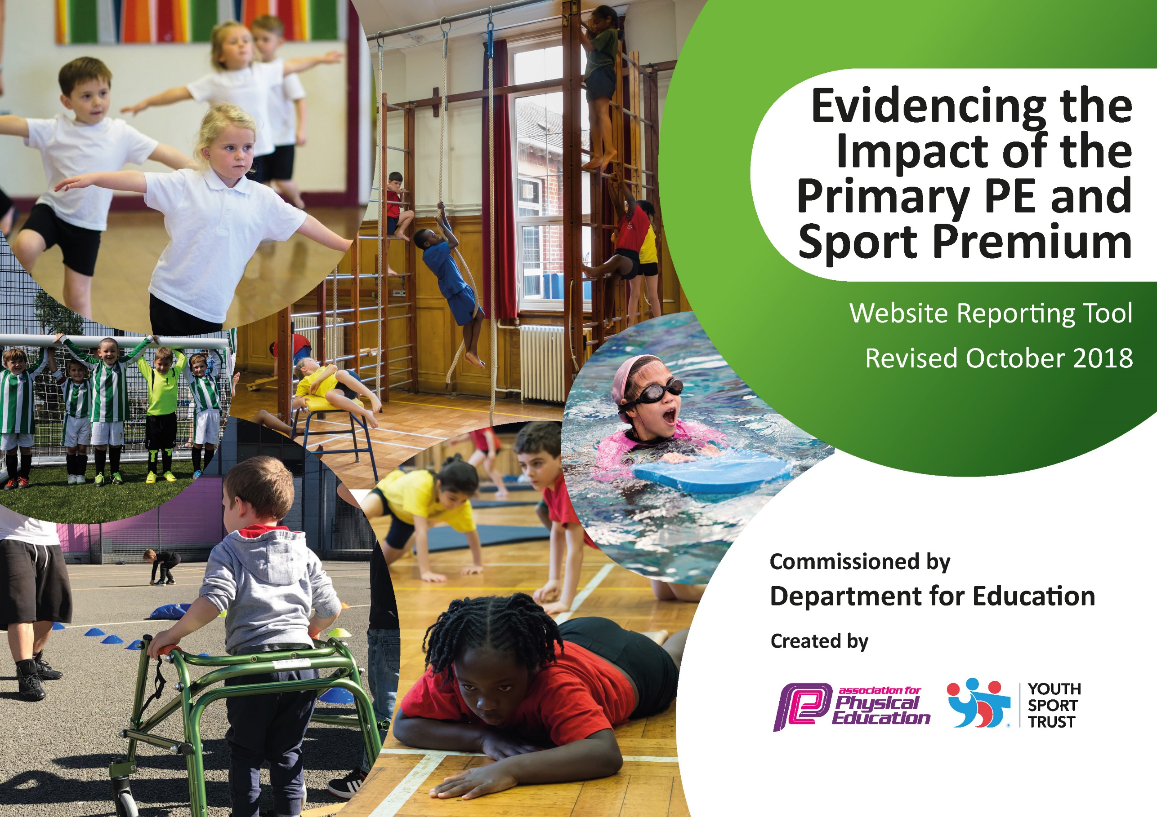

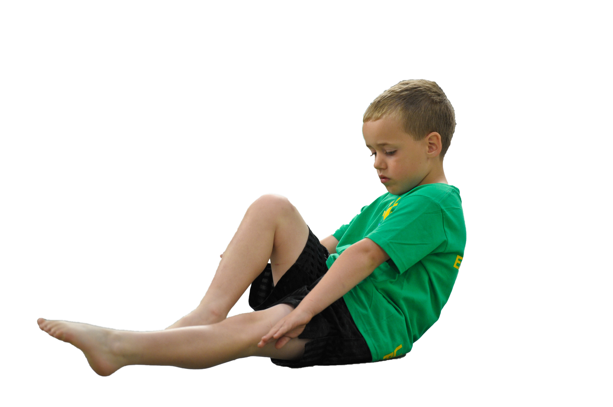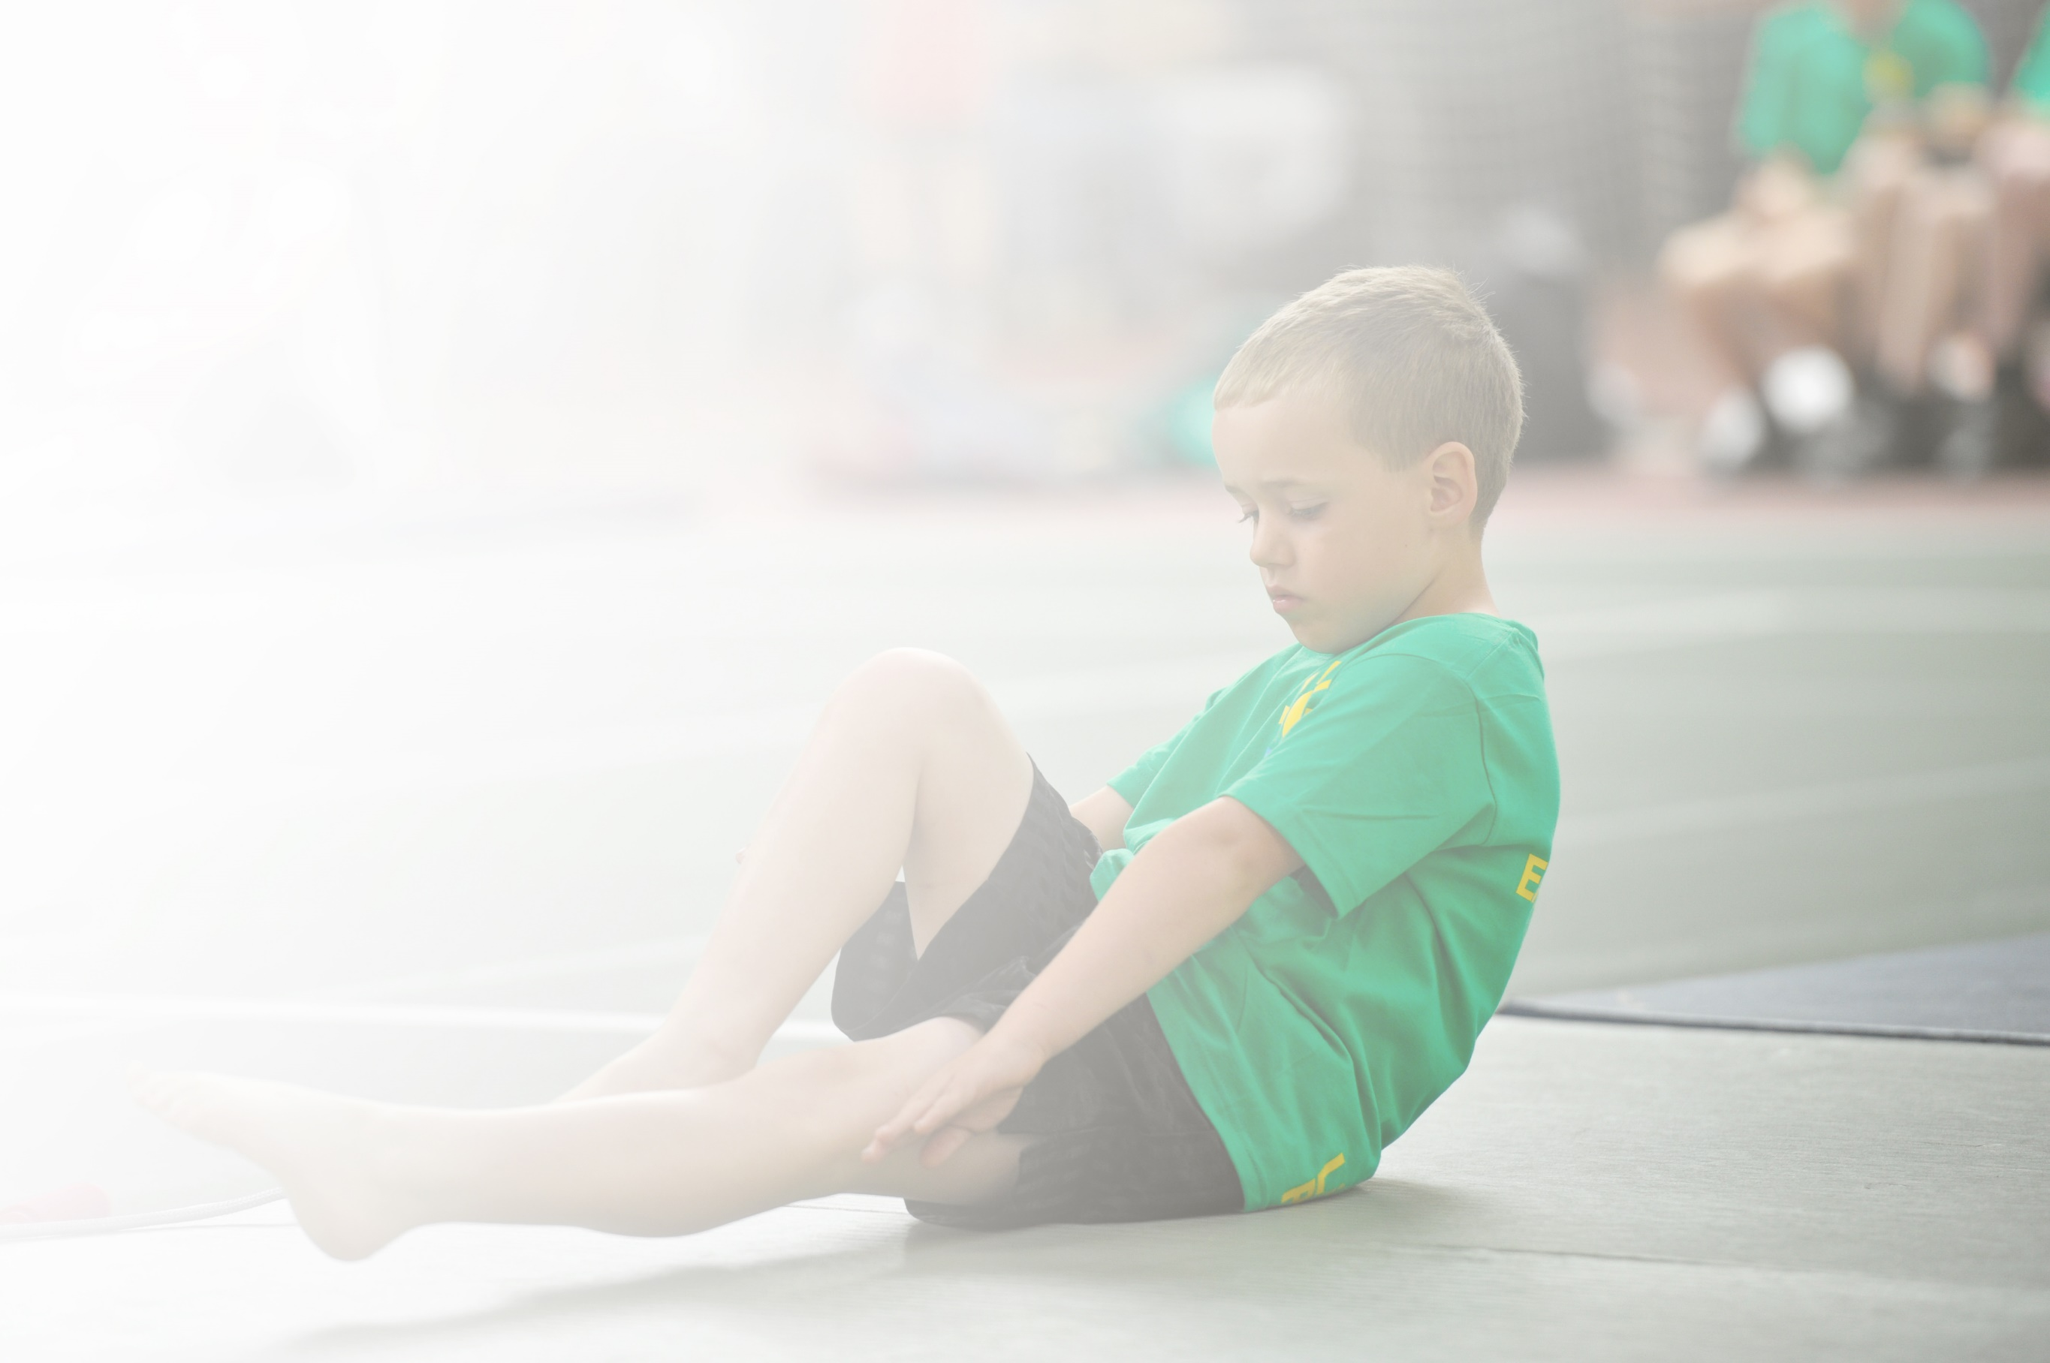Schools must use the funding to make **additional and sustainable** improvements to the quality of Physical Education, Sport and Physical Activity (PESPA) they offer. This means that you should use the Primary PE and Sport Premium to:

* Develop or add to the PESPA activities that your school already offer
* Build capacity and capability within the school to ensure that improvements made now will benefit pupils joining the school in future years

Please visit [gov.uk](https://www.gov.uk/guidance/pe-and-sport-premium-for-primary-schools) for the revised DfE guidance including the 5 key indicators across which schools should demonstrate an improvement. This document will help you to review your provision and to report

your spend. DfE encourages schools to use this template as an effective way of meeting the reporting requirements of the Primary PE and Sport Premium.

We recommend you start by reflecting on the impact of current provision and reviewing the previous

spend. Under the [Ofsted Schools Inspection Framework](https://www.gov.uk/government/publications/school-inspection-handbook-from-september-2015), inspectors will assess how effectively leaders use the Primary PE and Sport Premium and measure its impact on outcomes for pupils, and how effectively [governors](https://www.gov.uk/government/publications/governance-handbook) hold them to account for this.

Schools are required to [publish details](https://www.gov.uk/guidance/what-maintained-schools-must-publish-online#pe-and-sport-premium-for-primary-schools) of how they spend this funding as well as on the impact it has on pupils’ PE and sport participation and attainment by the end of the summer term or by **31 July 2019** at the   
latest.   
  
We recommend regularly updating the table and publishing it  
on your website throughout the year, as evidence of your   
ongoing review into how you are using the money to   
secure maximum, sustainable impact. To see an   
example of how to complete the table please   
click [HERE](http://www.afpe.org.uk/physical-education/wp-content/uploads/afPE-Example-Template-Indicator-2018-Final.pdf).

Support for review and reflection - considering the 5 key indicators from DfE, what development needs are a priority for your setting and your students now and why? Use the space below to reflect on previous spend, identify current need and priorities for the future.

|  |  |
| --- | --- |
| Key achievements to date: | Areas for further improvement and baseline evidence of need: |
| * St Mary’s awarded Gold Award by School Games Mark for second year running * All pupils active for at least an hour a day through daily run, regular skipping, active lunchtimes * KS2 pupils have two hours PE teaching a week * Teams from St Mary’s take part in all local competitions run by the Purbeck School Sports Partnership and achieve outstanding results. * Teachers receive regular CPD opportunities and are confident teaching PE | * All KS2 pupils to attend at least one extra-curricular club and increase percentage of girls participating * Partnerships with local providers to provide extra-curricular outdoor education activities * Improve facilities so pupils have experience of full court experiences for competitive games * Provide opportunities for pupils to have access to climbing equipment during playtimes to enhance playtime experience * Targeted provision for non-swimmers through KS2 |

|  |  |
| --- | --- |
| Meeting national curriculum requirements for swimming and water safety | Please complete all of the below: |
| What percentage of your current Year 6 cohort swim competently, confidently and proficiently over a distance of at least 25 metres?  **N.B.** Even though your children may swim in another year please report on their attainment on leaving  primary school. | 93% |
| What percentage of your current Year 6 cohort use a range of strokes effectively [for example, front crawl, backstroke and breaststroke]? | 93% |
| What percentage of your current Year 6 cohort perform safe self-rescue in different water-based situations? | 90% |
| Schools can choose to use the Primary PE and Sport Premium to provide additional provision for swimming but this must be for activity **over and above** the national curriculum requirements. Have you used it in this way? | No |

**Action Plan and Budget Tracking**

Capture your intended annual spend against the 5 key indicators. Clarify the success criteria and evidence of impact that you intend to measure to evaluate for students today and for the future.

|  |  |  |  |  |
| --- | --- | --- | --- | --- |
| **Academic Year:** 2018/19 | **Total fund allocated:** £17,980 | **Date Updated:** | |  |
| **Key indicator 1:** The engagement of all pupils in regular physical activity – Chief Medical Officer guidelines recommend that primary school children undertake at least 30 minutes of physical activity a day in school | | | | Percentage of total allocation: |
| 56% |
| School focus with clarity on intended **impact on pupils**: | Actions to achieve: | Funding allocated: | Evidence and impact: | Sustainability and suggested next steps: |
| Second and final payment for installation of astro pitch on one end of the school field.  Continue to run regular whole school skipping sessions | Ensure compliance with contract and all works finished to required standard  Review in-school and extra curricular provision to ensure maximum use from astro  Change organisation of daily run to utilise new resource. | £10,000 astro | Used for EYFS/KS1 daily run instead of tarmac/bank area. Much safer and better quality run.  Four lunchtime clubs can now be run weekly and younger children participate more. Accessed by care provision before and after school.  More than one sports club after school has been offered.  65% of total pupils took regular part in an extra-curricular club during 2018-19 (66% of SEN and 73% EAL) | Need to provide walkway to astro that prevents pupils from getting wet/muddy when accessing astro during winter months.  Astro is major asset to quality and quantity of sports provision going forwards.  Maintain quality of surface by renewing sand if needed.  Improve playground equipment  Increase participation of girls in extra curricular activities  (89% of boys, 48% of girls 2018-19) |
| **Key indicator 2:** The profile of PESSPA being raised across the school as a tool for whole school improvement | | | | Percentage of total allocation: |
| 12% |
| School focus with clarity on intended **impact on pupils**: | Actions to achieve: | Funding allocated: | Evidence and impact: | Sustainability and suggested next steps: |
| Bronze ambassador sport leadership scheme promoted. Leaders involved in running lunchtime clubs for younger pupils.  St Marys’s works towards Gold Award from Youth Sports Trust for second year.  Absolute coaching software package | Increase the range of sports pupils experience and compete in  Increase the number of pupils involved in extra curricular activities.  Target less active pupils to engage in some extra curricular sports activity,.  Create new sports leadership awards for presentation annually to Y6 pupils. | £1700 Purbeck School Sports Partnership  £145 trophy costs  Absolute coaching £325 | Increased participation in competitive events – more sports and more children.    Gold Award achieved  Improving percentage of pupils taking part in extra curricular physical activity | Continue commitment to retaining Gold Award from Youth Sports Trust  Ensure every child in KS2 involved in some sort of extra curricular club  New curriculum intent reflects ethos where active learning is encouraged. |

|  |  |  |  |  |
| --- | --- | --- | --- | --- |
| **Key indicator 3:** Increased confidence, knowledge and skills of all staff in teaching PE and sport | | | | Percentage of total allocation: |
| 1% |
| School focus with clarity on intended  **impact on pupils**: | Actions to achieve: | Funding  allocated: | Evidence and impact: | Sustainability and suggested  next steps: |
| CPD provided to staff either internally or externally to ensure all teachers confident teaching PE.  Strong PE leadership | All KS2 pupils receive two hours of high quality PE teaching a week | £250 | Staff confident in teaching PE and all deliver lessons | Skills progression for PE shared with all staff and used to map curriculum effectively  Provide CPD for staff on outdoor education next year. |
| **Key indicator 4:** Broader experience of a range of sports and activities offered to all pupils | | | | Percentage of total allocation: |
| 14% |
| School focus with clarity on intended  **impact on pupils:** | Actions to achieve: | Funding  allocated: | Evidence and impact: | Sustainability and suggested  next steps: |
| Additional achievements:  Hockey coaching part of PE curriculum and after school provision.  Outdoor education accessed by all  pupils and for targeted groups.  Strong with local hockey, tennis and cricket clubs. | Qualified hockey coach for after school KS2 club    Beach and forest school provision | £1075 specialist coaching  £1363 | Many pupils from St Mary’s have joined Purbeck Hockey Club after  school experience.  Number of girls playing football has increased, local girls football team started with number of StM pupils | Broaden range of after school clubs 2019-20  Develop opportunities for outdoor education/activity within the curriculum |
| **Key indicator 5:** Increased participation in competitive sport | | | | Percentage of total allocation: |
| 17% |
| School focus with clarity on intended  **impact on pupils**: | Actions to achieve: | Funding  allocated: | Evidence and impact: | Sustainability and suggested  next steps: |
| Full participation in events/competition calendar through membership of Purbeck and East Dorset School Sports Partnership.  Resources and facilities regularly improved or replaced when needed.  Cost of transport to and from fixtures, cost of cover for PE leader | Attend all possible fixtures and events in Purbeck Competition Diary  Increase the number of pupils involved in competitive fixtures.  Improve the level of performance through high quality coaching and teaching | £2253  Equipment  Transport £528  PE cover £346 | Success in range of sporting competitions. Won Purbeck events in nearly every fixture.  Retained Purbeck Football Cup, Purbeck Schools Tennis Trophy, runners up in county finals in netball, girls football and athletics.  31 competitions entred in summer term. 66% of pupils participated in a school games competitive event. | Full commitment to next years competition diary run by Purbeck School Sports Partnership, local sports clubs and organisations.  Continue to run own hockey tournaments.  Trial cross country events |