Expressive Arts and Design  We will be exploring lots of different textures and patterns as well as focusing on our painting techniques.  In our music lessons we will be creating rhythms, exploring the sounds of different instruments and recording our own music. | Communication and Language  We will be learning to express our point of view clearly with our friends and adults. We will continue to understand how important listening to others is.  We will also focus on listening to and following multi-part instructions and continue to learn lots of new vocabulary from stories. | Understanding the World  We will be looking at where in the world our food comes from and what the weather is like in the places the food comes from.  We are going to be looking at the importance of healthy food choices and creating a healthy lifestyle. We are going to be trying lots of different foods and exploring the different textures and tastes.
RE  In RE we will be learning about the celebrations in Church that happen throughout the year, whether that be regular celebrations or unexpected surprises. We will then look at our topic of gathering and exploring our Church family. | 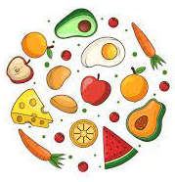  Food,  Glorious Food | PSHE  This term we are going to be looking at keeping our bodies healthy and active. We will be thinking about healthy food and a good night’s sleep. We will then look at our resilience and how we can bounce back when things go wrong.
Maths  This term in maths we will be focusing on the numbers to 5. We will be looking at change within 5, number bonds within 5 and space. We will then move onto looking at numbers to 10, comparing the numbers within 10 and addition to 10. | Physical Development  In our PE lessons this half term we will be focusing on dance. We will be moving to music is lots of creative ways and practising our balance skills.  We will also be working on our gross motor skills through play in the outdoor area. | Phonics  This term in Literacy we will be focusing cementing our knowledge of our set 1 sounds.  We will be focusing on reading simple words using our “Special Friend, Fred Talk, Read the word” technique.  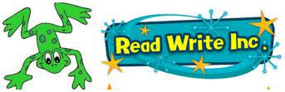  We will continue to practise our letter formation with the support of our handwriting rhymes. We will start to write CVC words using our Fred fingers to help us.
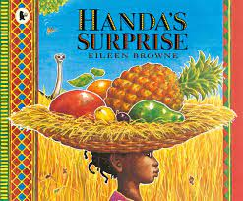
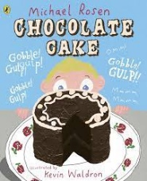
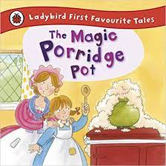
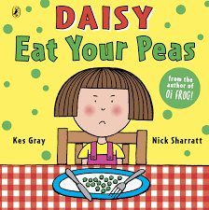
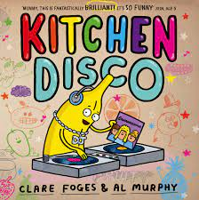
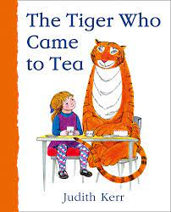
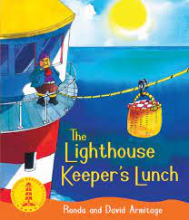
Key Books

