

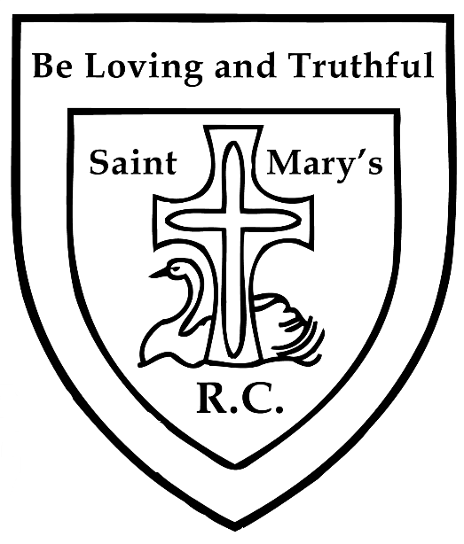
CLOTHING POLICY

REVIEWED: 26th January 2021
NEXT REVIEW: Spring 2024

Our Mission Statement
To provide an environment that nurtures all towards the fullness of life that comes from God and a curriculum that expands our children’s horizons; a place where all can realize their potential – intellectual, spiritual, moral, physical and emotional; and where our children are prepared to take their places as effective, caring and respectful global citizens.

Our Ethos
To value and appreciate everyone.
To try our best at everything.

Saint Mary’s Catholic
Primary School
Swanage

The Governors of St Mary’s Catholic Primary School agree that the children at the school should wear uniform.

School Uniform Grant Scheme

Parents who are in receipt of free school meals are entitled to apply for a grant towards the cost of uniform. Please note that this cannot be used for things such as coats or shoes that are needed by pupils outside school hours.

The Governors have agreed that the parents may claim £35 per child every two years. In order to be able to apply for the grant, the school will require receipts of uniform purchased. Parents may also request that uniform is purchased with the grant directly by the school from Purbeck Embroidery.

Parents will need to apply for the grant in writing to the school office giving details of their needs.

The School Uniform is:

Boys: Grey trousers/shorts, blue polo shirts, school sweatshirt, grey or white socks and school shoes not trainers.

Girls: Grey skirt/pinafore or trousers, blue polo shirts, school sweatshirt or cardigan, white or grey socks and school shoes not trainers.

PE Kit: Blue school sports hoodie, navy joggers, navy shorts or skorts, house colour t-shirt, football/sports socks and trainers.

Long hair should be tied up/back to keep hair off children’s faces during learning and to help control the spread of head lice. All pupils with hair below their collar are expected to have it tied up for PE lessons and for practical activities where it is assessed as a risk for health and safety.

For health and safety reasons we do not allow children to wear jewellery. The exceptions to this rule are ear-ring studs in pierced ears, and small objects of religious significance. Children are required to remove any items during PE lessons to prevent them from causing injury.

Please note: Teachers are not permitted to remove earrings. Hair bands, ribbons/bows or ‘scrunchies’ should be plain and practical. Hair bands should not have large flowers attached. Make up and nail varnish should not be worn to school unless for an out of school hours function, for example a school disco. Extreme hairstyles are not appropriate for school. The use of styling products should be kept to a minimum and children should not have decorative patterns cut into their hair or have hair coloured or dyed.

