HOME - SCHOOL AGREEMENT

St Mary’s Primary School welcomes you and your child into our Catholic community.

We believe that parents are the first and foremost educators of their children, and that we are called to support them in their God-given task. We value each child in our school and encourage them to develop their knowledge, experience, understanding and confidence in a happy atmosphere where the child and parents feel comfortable, and where our Catholic values are embedded in our school ethos

We ask you as parents to enter with us into an Agreement of Partnership. Please read the attached pages and then sign and return the agreement.

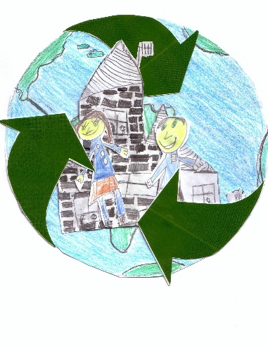
St. Mary’s Catholic Primary School

Home-School Agreement

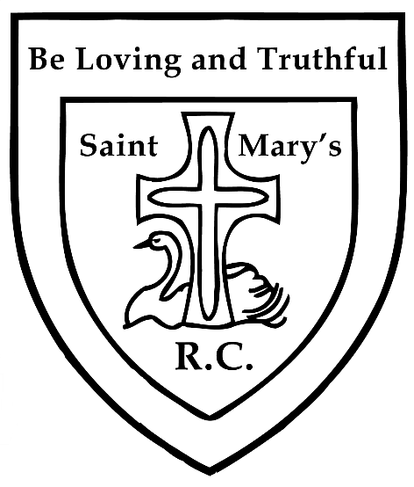
A partnership between the school, parents/guardians and pupils.

We acknowledge our responsibility to support parents/guardians in their task of nurturing their children towards human wholeness within a Catholic/Christian Community.

Our Ethos

To value and appreciate everyone

To try our best at everything

Our Motto

Be Loving and Truthful

Our Mission Statement

To provide an environment that nurtures all towards the fullness of life that comes from God and a curriculum that expands our children’s horizons; a place where all can realize their potential - intellectual, spiritual, moral, physical and emotional; and where our children are prepared to take their places as effective, caring and respectful global citizens.

Staff and Governors will: -
- Keep your child safe whilst they are in our care.
- Provide a secure, stimulating and Christian environment in which to learn and where all members of the school community are role models for Gospel Values in action.
- Maintain, preserve and pass on the faith and teaching of the Catholic Church. We affirm the important role of the Parish Priest in the life of the school.
- Contact you if there is a problem with your child’s attendance, punctuality, behaviour or health.
- Provide you with: information about your child’s progress and opportunities to speak to teachers.
- Keep you informed about school policies and activities through regular letters, School Buddy and the school website.
- Provide a challenging teaching and learning programme that meets statutory requirements, is engaging, recognises individuality and develops the attributes necessary for becoming a successful learner.
- Be open and welcoming to parents/carers and where appropriate offer opportunities for them to become involved in the daily life of the school.
- Provide regular information regarding current e-safety.
- Not tolerate bullying in any form: physical, cyber-based or emotional.
- Ensure the appropriate security of any personal data in line with Data Protection legislation.
Sandy Porter (Chair of Governors)
- Parents/Guardians will: -
- Support the Catholic ethos and Mission Statement of St Mary’s R.C Primary.
- See that our child attends school regularly, on time and suitably dressed and equipped.
- Avoid taking our child out of school for holidays during term time.
- Inform school of any illness/absence by telephoning or emailing before the close of morning registration.
- Inform the school of any concerns or problems that might affect our child.
- Attend parent evenings and discussions about our child’s progress.
- Support the school’s policies and guidelines.
- Be aware of the importance of emotional well-being, good nutrition, hydration, exercise and sleep in relation to our child’s readiness to learn.
- Give our child opportunities for home learning e.g. read with our child and support homework from school.
- Talk to our child about his /her experiences in school and encourage them to be enthusiastic learners and do their best.
- Respect and support staff judgements and professional expertise.
- Encourage our child to show kindness and consideration to others.
- Value the role of the school in the local community.
- Behave appropriately on school premises at all times.
- Not discuss school based issues, school staff, pupils or parents on social media sites.
- Keep up to date with current e-safety information.
Signed _______________________________

Print Name ___________________________

Pupils will: -
- Never be afraid to ask for help
- Be aware of my rights and responsibilities
- Live out our Gospel Values and follow the school behaviour policy
- Bring all the equipment I need each day
- Take care of our whole school environment and be aware of our eco code.
- Develop my learning by:
- Working hard
- Understanding others
- Concentrating
- Trying new things
- Using my imagination
- Pushing myself
- Trying to improve
- Not giving up
Signed ___________________________

Print Name _____________________

