Expressive Arts and Design  We will be painting patterns on animals, choosing colours and using shapes within our drawings. We will explore lots of different artistic effects to express our ideas and feelings.  In our music lessons we will changing our voice and listening and responding to different styles of music. We will also create our own songs and play instruments with increasing control. | Communication and Language  We will be continuing to work on sharing our ideas in small groups and with the class. We will think about using connectives to link our ideas together and continue to learn vocabulary so we can describe our ideas in detail.  This term we will continue to enjoy our story times each day and think about the main characters in our stories, their feelings, actions and motives. | Understanding the World  We will be looking at lots of animals that live on farms, as well as mini beasts and insects that we find in our local area. We will explore the lifecycles of ducks, butterflies and frogs.  We will look at the changes that spring brings and what plants need to grow. We will explore maps of our local area and the world looking at our map reading skills and the language needed for directions.
RE  In RE our topic is called Growing. We will be thinking about the changes that happen in the spring time and that Spring is a time when things begin to grow. We will also look at Lent and think of it as a time we can grow in love to be more like Jesus and look forward to Easter. | 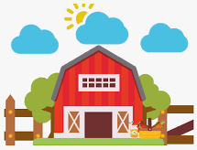  Down on the Farm | PSHE  This half term we will continue to think about our resilience when we find things tricky and how we develop our problem-solving skills. We will work on listening to others and show kindness and support to our friends.
Maths  This half term in maths we will cover;  Measure – length, weight and height  Number bonds to 10  Subtraction within 10  Exploring patterns | Physical Development  In our PE lessons this half term we will continue working on our dance skills and move onto practising our aiming skills.  We will continue to develop our fine motor skills with lots of funky finger activities and practise correct letter formation with the help of our handwriting rhymes. | Phonics  This term in Literacy we will begin to learn our set 2 special friends. We will focus on spotting our new sounds in words using our “Special Friend, Fred Talk, Read the word” technique. We will begin to learn red words; these are words that we cannot use our Fred talk to read.  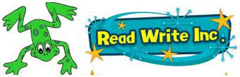  We will continue to practise our letter formation with the support of our handwriting rhymes. We will start to write words and sentences using our Fred fingers to help us.
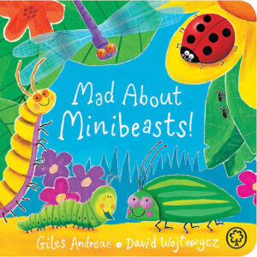
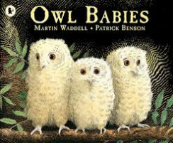
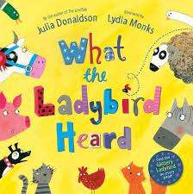
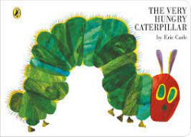
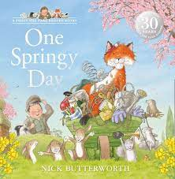
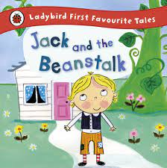
Key Books

